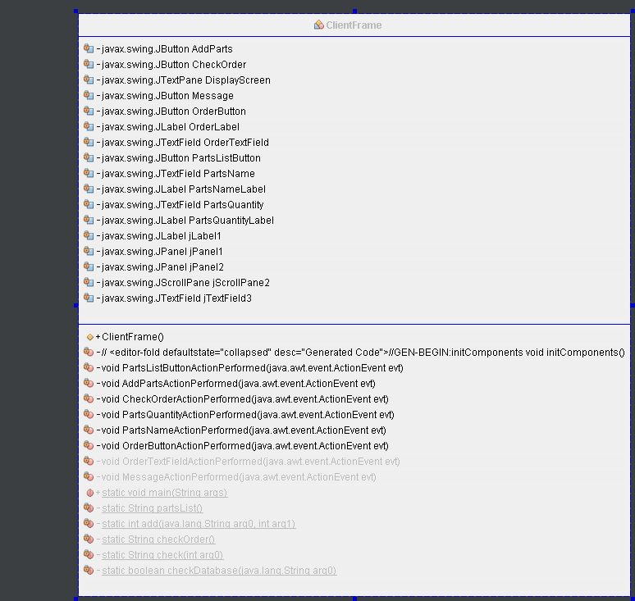

This application is based on a parts purchase. The interface is based on a java application which uses a JFrame. There are a few buttons which does different web services and a button which also sends zeroQ messages to a server to let the server know what is currently on the parts list.

**This is the interface of the application**

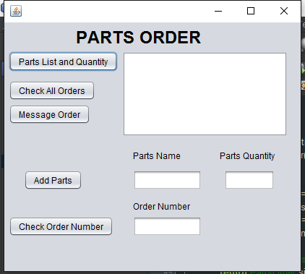

**Parts List and Quantity Button**This button allows the client to show what parts are in stock and the price. These data are stored in a database and when the button is pressed it retrieves the data from the database.

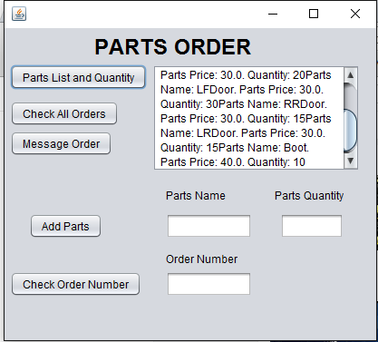

**Check All Order Button**  
This button allows the client to see what product has been ordered and the quantity of the item. The orders will be added to the order list if the part Name is a valid part.

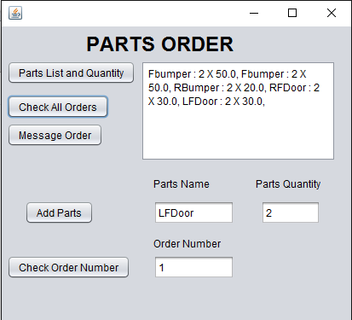

**Message Order**  
this button sends the parts order to the server by using zeroMQ Messaging. So the Server can process the order and update the database when it is completed. This picture bellow is the message the server receives when the order has been sent through.  


**Add Parts Button**  
This button allows the user to add parts to the order. This will add the parts and the quantity to the order only if the part name is valid. If the part name is not vaild, the item will not be added onto the parts list.  
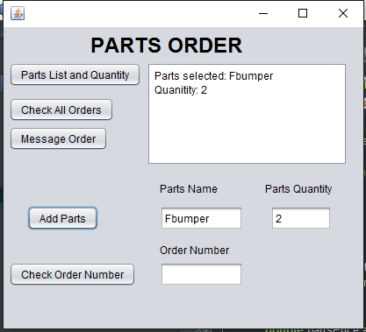

**Check Order Button**  
This button is to check the items of order of which was added. A remove method was implemented but for some reason the Web service had trouble implementing it. When it was run on the tester it would work but as soon as I tried to implement it into the Jframe it would not work.

